**Currency Converter Requirements**

Roles

* View Paul Trimor
* Controller Dung Nguyen
* Model Aaron Lewis

Layout Requirements

* The user will have access to two pages, the Login page and the Main page.
* The Login page will display two forms allowing the user to login and register themselves.
* The Main page should contain a nested layout of the Converter feature and the user information.

Converter Feature

* The Converter feature shall allow the user to input a financial amount in a text box and convert to a selected currency.
* The user shall be able to select what currency to convert to out of a dropdown.
* The user shall be able to between the two conversions by a click of a button.

User Display Information

* On the first visit to the User Display, the user will be able to select their “Native Country”.
* After every conversion, the User Display shall display the “Last Conversion Country”
* The system shall display a list of all past conversions made by the user.

Walkthrough

* User run jar and a jFrame with a logo appear. Then dialog appear for User to login or sign up. JFrame then go to the main converter panel. The Converter panel contain US Dollar on the left and other country currencies on the right. We will use desktop panel to have multiple session of converter. In each session we will have 4 buttons: switch button to switch from and to currencies, convert button to do the conversion, Clear button to clear both to and from text field, and a Log button to show 10 most recent logs. We will also have a user profile panel which will show user info and activity. The user profile panel will exist inside of the desktop panel, but not in any internal frames.

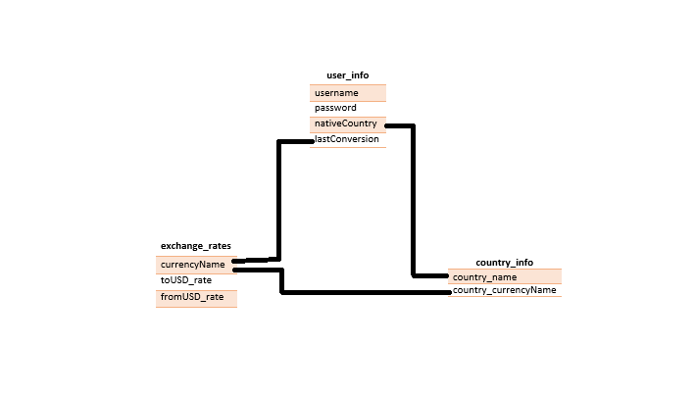

We are using mySQL Workbench as our database for this project. In addition to the database outlined above, we are also going to save the logs of each conversion to a CSV file, which we will use when displaying the logs later.

